BI4Cloud - Business Intelligence

Key Benefits to Save you Time and Help your Clients Run their Business Smarter using MYOB
- Dashboards to Detail
- Flexible business reports to help unlock valuable MYOB data
- Auto Email any reports and setup alerts (e.g. Sales below margin, Jobs over budget)
- Consolidate multiple MYOB files – GL, Jobs, Sales, Customers, Purchases, AR, AP etc
- Comparison reports to any prior periods
- Reports available on the Cloud from any browser including from iPad and Macs

How to Identify clients who could benefit from an Add-on to standard MYOB
- Using multiple spreadsheets to help run their business
- Asking for functionality or information not readily available in MYOB
- Inefficient business processes

Boost your Advisory Skills using BI4Cloud – Business Intelligence

Identify a client using MYOB for one of the four following areas.

Connect-up their MYOB file to BI4Cloud then work through the following GAP Analysis examples to learn how to have a deeper conversation about their business. Help clients to manage margins and job profitability, save time, show them how to use MYOB for CRM, to get more from their MYOB and to see their business as never before.
- All-inclusive month end P&L and/or Consolidated P&L
- Item Sales & Inventory
- Manage Projects Type Jobs
- Run Divisions or Cost Centres with Budgets

Superpowers – Available now out of the box from $40+gst/mth

All-inclusive month end P&L and/or Consolidated P&L

P&L Act v Bud inc Last year - Ultimate Month end P&L

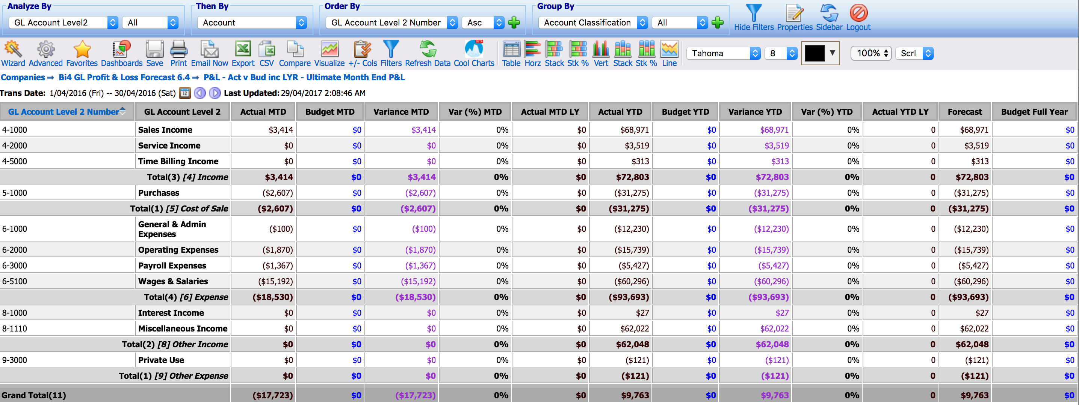

Relevant for:
- All types of businesses
Learn more
- GL - Ultimate month end P&L
- Jobs – Ultimate month end P&L

Item Sales & Inventory

Item Sales – Comparison Sales by Customer

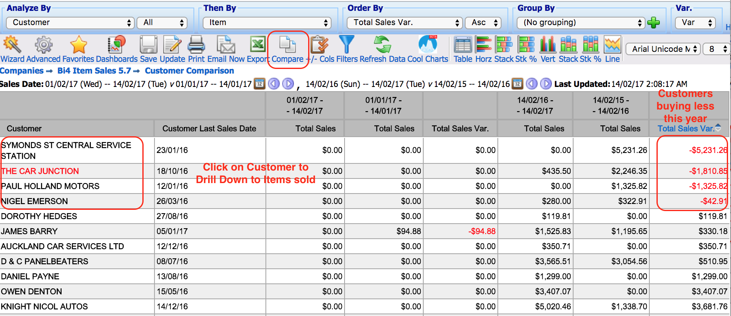

Relevant for:
- Wholesale Distribution / Item Sales businesses
Learn more
- Which Customers Have Stopped Buying
- How Business Intelligence can help drive CRM
- Use Custom Lists to Group Customers and Items together

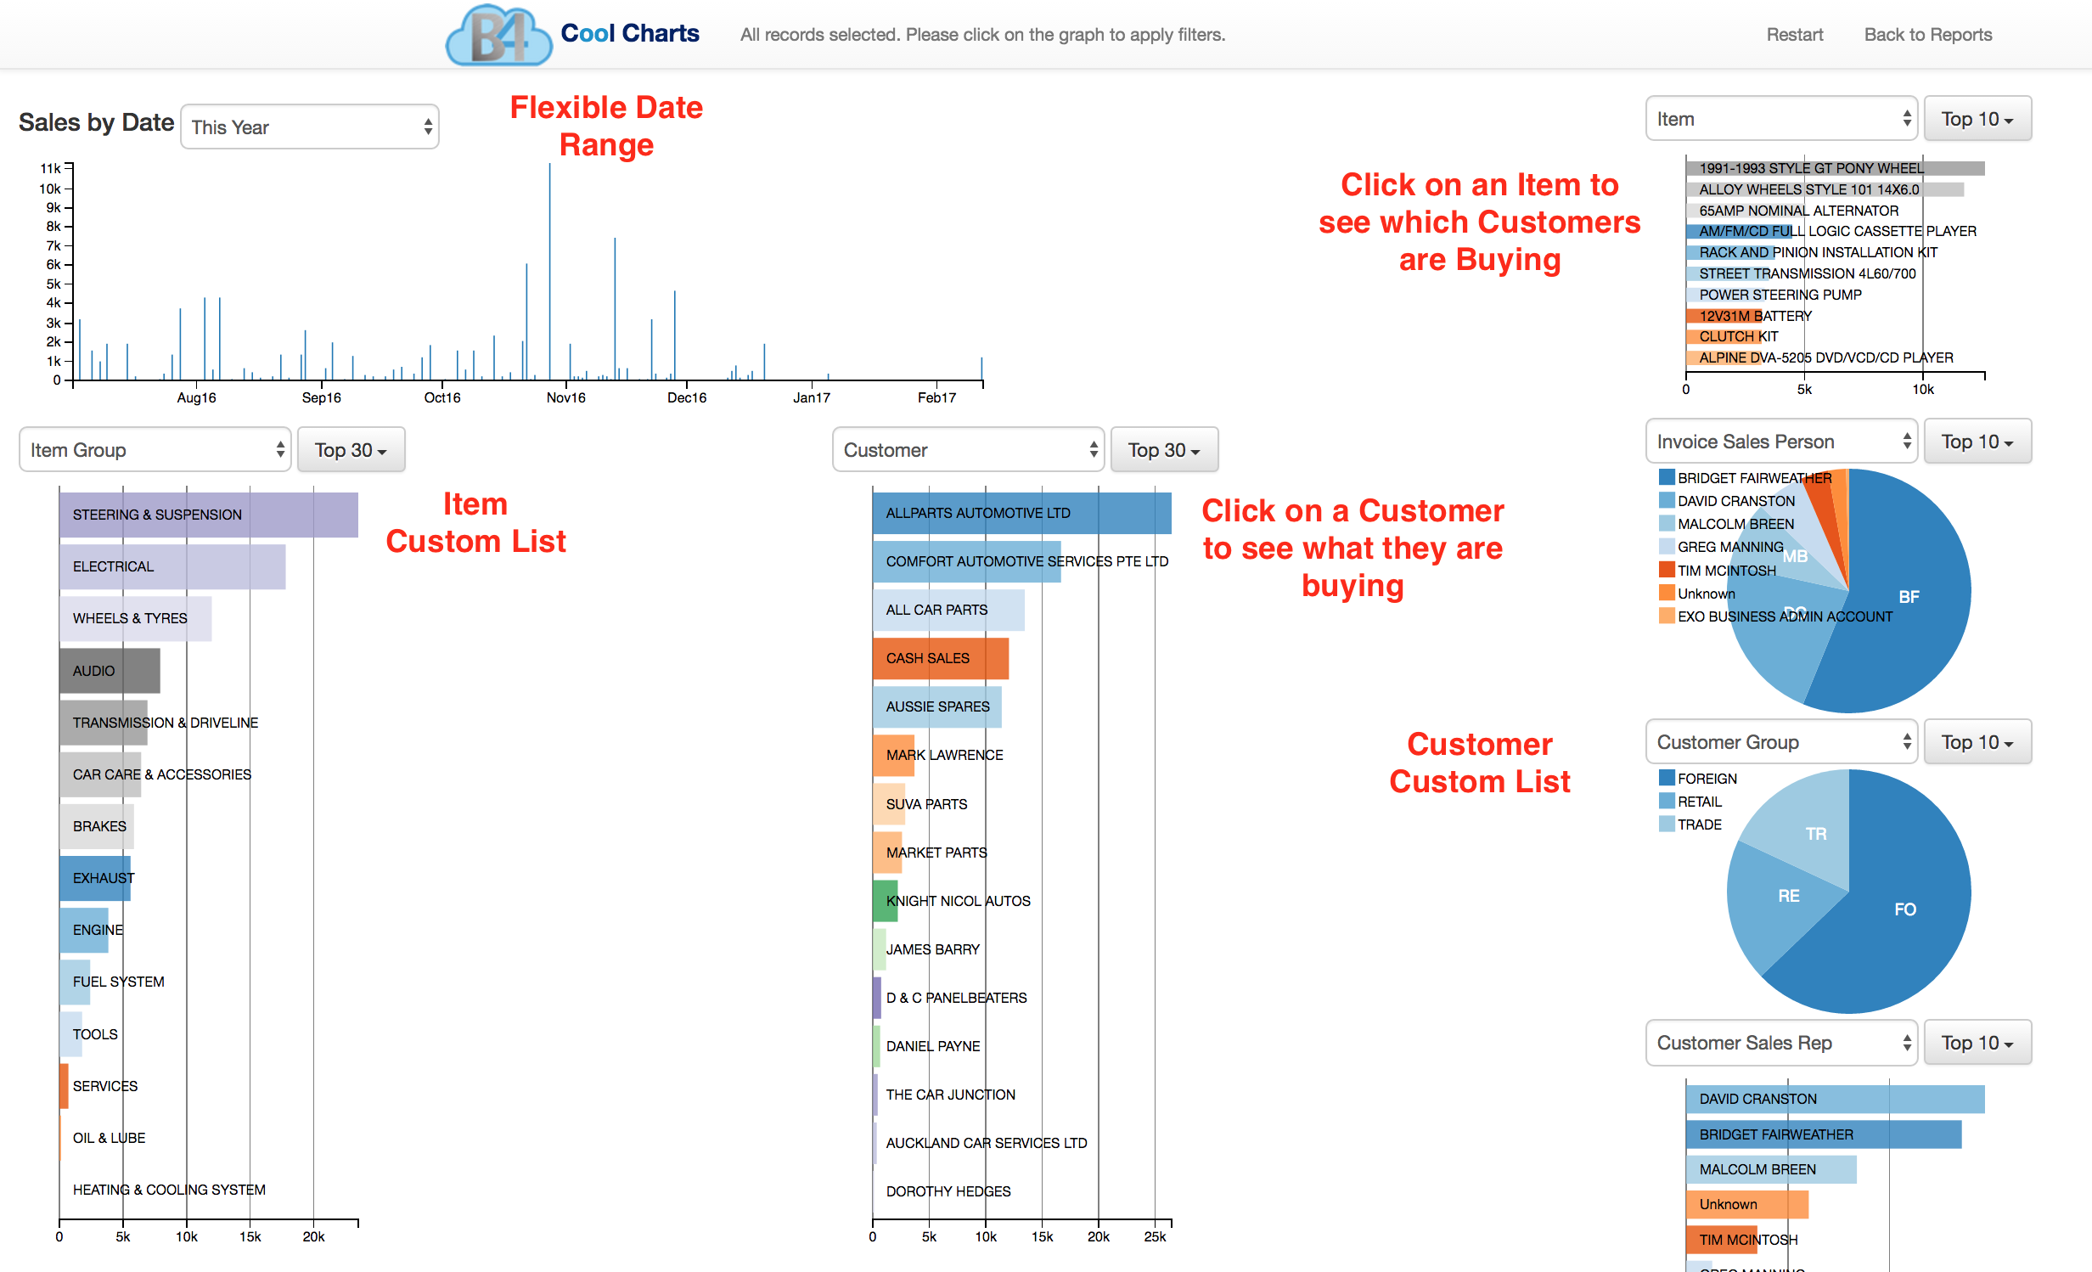
Learn more:
- Cool Charts – Dynamic Sales Analysis

Manage Projects Type Jobs

Job Actual v Budget including Orders

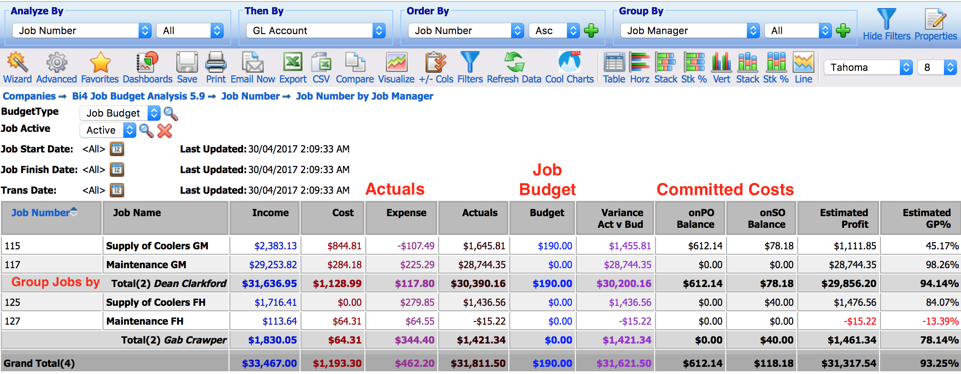

Relevant for:
- Construction, engineering, building
- Services e.g. landscaping, recruitment, maintenance
- Events e.g. concerts, conferences, festivals
Learn more:
- Use Jobs to manage Project type Jobs & WIP
- Super charge your Jobs reporting to better manage Project type Jobs

Run Divisions or Cost Centres with Budgets

Job Actual v Monthly Budget – YTD by Job

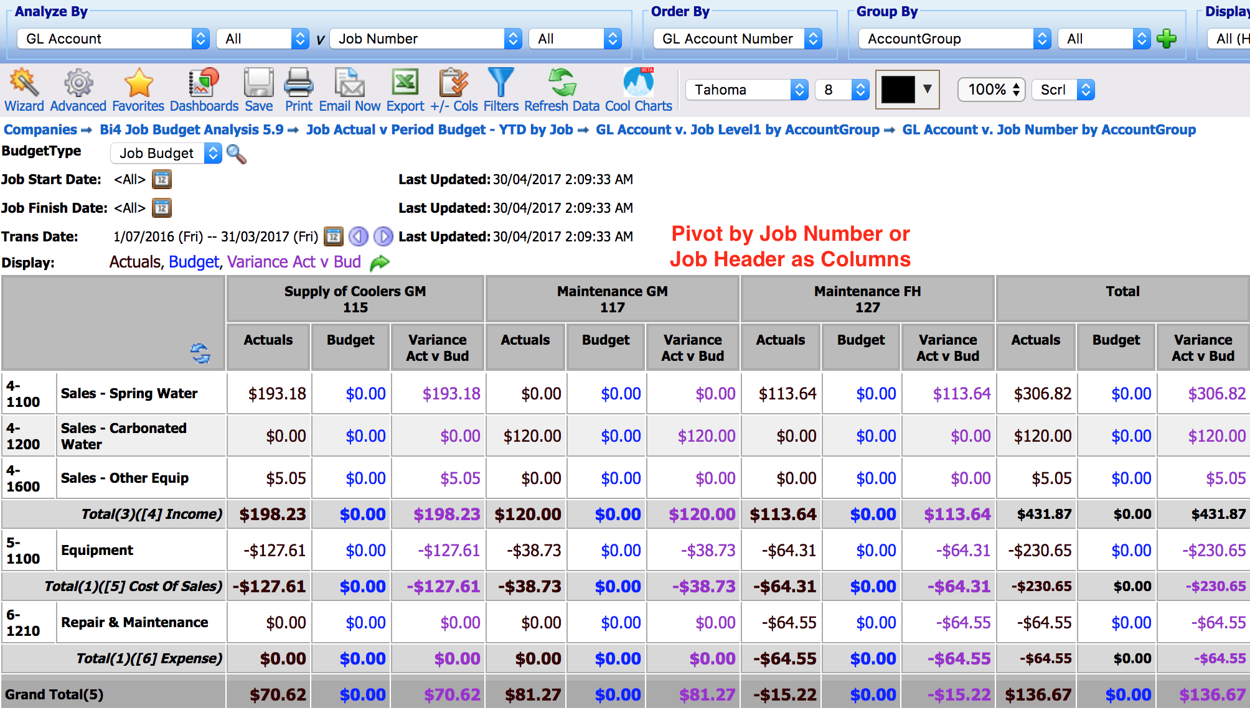
Relevant for:
- Businesses with Multi Branch, Divisions, Multi State, Cost Centres etc.
- Not for Profits – NFP and organisations on the NDIS
Learn more:
- Use Jobs to run Departments or Cost Centres with Monthly Job Budgets
- Jobs – Ultimate month end P&L

